**Cache Memory**

**Cache Memory is a special very high-speed memory. It is used to speed up and synchronizing with high-speed CPU. Cache memory is costlier than main memory or disk memory but economical than CPU registers. Cache memory is an extremely fast memory type that acts as a buffer between RAM and the CPU. It holds frequently requested data and instructions so that they are immediately available to the CPU when needed.**

**Cache memory is used to reduce the average time to access data from the Main memory. The cache is a smaller and faster memory which stores copies of the data from frequently used main memory locations. There are various different independent caches in a CPU, which store instructions and data.**

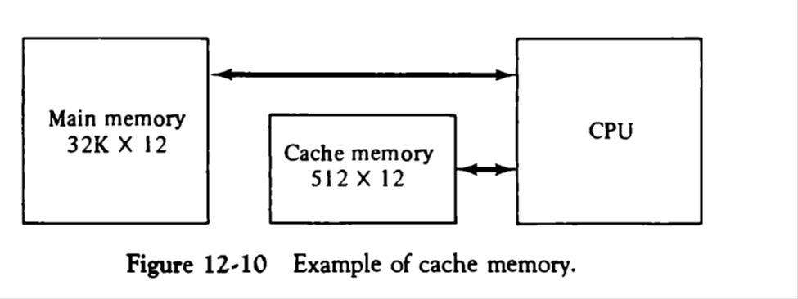

**Cache Performance:**

**When the processor needs to read or write a location in main memory, it first checks for a corresponding entry in the cache.**

**If the processor finds that the memory location is in the cache, a cache hit has occurred and data is read from cache**

**If the processor does not find the memory location in the cache, a cache miss has occurred. For a cache miss, the cache allocates a new entry and copies in data from main memory, and then the request is fulfilled from the contents of the cache.**

**The performance of cache memory is frequently measured in terms of a quantity called Hit ratio.**

**Hit ratio = hit / (hit + miss) = number of hits/total accesses**

**We can improve Cache performance using higher cache block size, higher associativity, reduce miss rate.**

**Virtual Memory**

**Virtual memory is a valuable concept in computer that allows us to run large, sophisticated programs on a computer even if it has a relatively small amount of RAM. Virtual memory is a feature of an operating system that enables a computer to be able to compensate shortages of physical memory by transferring pages of data from random access memory to disk storage. This process is done temporarily and is designed to work as a combination of RAM and space on the hard disk.**

**Paging**

**Virtual memory breaks programs into fixed-size blocks called pages. If a computer has abundant physical memory, the operating system loads all of a program's pages into RAM. If not, the OS fits as much as it can and runs the instructions in those pages. When the computer is done with those pages, it loads the rest of the program into RAM, possibly overwriting earlier pages.**

**Multiprogramming**

**Virtual memory with paging lets a computer run many programs at the same time, almost regardless of available RAM. This benefit, called multiprogramming, is a key feature of modern PC operating systems, as they accommodate many utility programs such as printer drivers, network managers and virus scanners at the same time as our applications -- Web browsers, word processors (Example MS Word), email and media players.**